- Log into Illuminate. Contact your site administrator if you encounter difficulties with your login. Note: If this is your first time to log in for this school year, your password is caddo1

- Your Illuminate home screen should display several tiles. If it does not, click on the colorful icon on the left hand side above your initials.

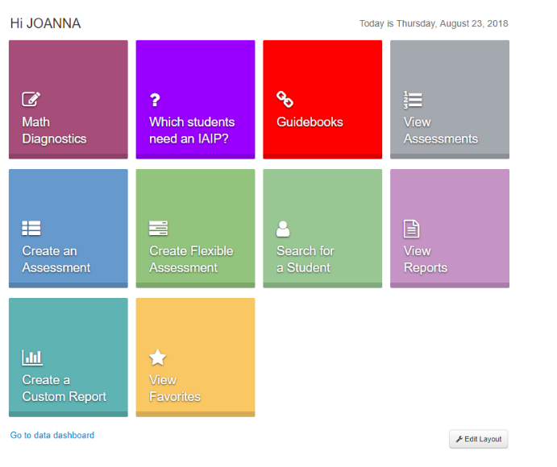

If your Illuminate home screen does not look like THIS

Go to the left hand side of the screen and click on the colorful Illuminate logo above your initials.

- Click on the “Guidebooks” tile.
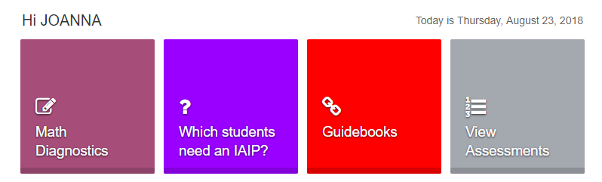

- Click on the Assessment that you are ready to use and proceed as usual. Note that clicking on the type “Assessment View” will pull up a complete list of assessments for that grade. 